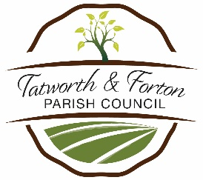

**NOTICE OF VACANCY**

**Join our local team and become a Parish Councillor**

**Are you passionate about your community? Do you want to help make a long-lasting change? Do you have innovative ideas for the council? Do you have concerns about a specific issue and want to do something about it? If this is you, then we need you. We need people from all backgrounds and experiences who reflect their community to put themselves forward for co-option to the Parish Council.**

**The Parish Council is entitled to have 12 council members and after recent resignation we now have a vacancy**

**No special qualification is required to be a councillor. It is important that all sorts of people serve as councillors to so that all parts of the community are represented. Training for new councillors is also available to help you understand the responsibilities of the role.**

**To request an application form or have any questions please contact the Parish Clerk Nigel Tinley. Please apply by 31st July 2025**

**The Parish Office The Memorial Hall TA20 2QA**

**01460 220063 Tuesday/Friday Morning**

**clerk@tatworthandfortonparishcouncil.org.uk**