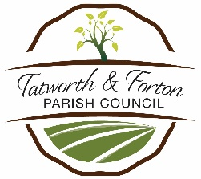

**TATWORTH AND FORTON PARISH COUNCIL**

**INVITES**

**GRANT APPLICATIONS**

**from**

**Parish based Groups and Organisations for**

**Grants up to £300.**

**Applications must be received**

**by 21st August 2025**

**Application Form on Website**

**Or contact the Parish Clerk**

**for an Application Form:01460 220063**

**or email:**

**clerk@tatworthandfortonparishcouncil.org.uk**