 **TATWORTH AND FORTON PARISH COUNCIL**

**NEWSLETTER**

**DECEMBER 2024**

Hello, welcome to our last newsletter of 2024 for the residents of Tatworth and Forton Parish.

Autumn is nearly over, especially with the recent snowfall, but hopefully the weather will not be too bad in the coming months.

***Councillors and vacancy***

As a Parish Council we have 12 Councillors coming from different walks of life living in Forton as well as Tatworth. They are volunteers who work for the benefit of the residents of Tatworth and Forton. Some are retired, others still work, but they all have a desire to improve our community and the area we live in and are prepared to give up a few hours of their time to try to achieve this. However, we do have a vacancy and if anyone is interested in serving the local community as a Parish Councillor please email the Clerk at clerk@tatworthandfortonparishcouncil.org.uk *This is your opportunity to have an influence on how the area changes.*

If you don’t want to become a Councillor but still have an interest in local amenities or the cemetery there is an opportunity to be co-opted on to these committees. We have one vacancy on each of the Amenity and Cemetery Committees. The meetings are held every two months. If anyone is interested please email the Clerk at the address previously stated.

**We would like to offer our thanks to David Peake who donated many hours to support the Council, being Chairman of both the Planning and Finance Committees. David has decided to devote his time to other matters.**

***Jubilee Field***

The development of this invaluable amenity continues with many improvements but the provision of a dedicated field for exercising and training of dogs off lead has not proved as popular as hoped. When funds allow, the council has discussed the provision of equipment for dog agility training. So far, increased grass cutting, security fencing and the installation of a sponsored bench have been approved. It is hoped that the bench will be provided via a memorial contribution rather than utilising general parish funds. If you are interested in donating in memory of a loved one please contact the Clerk. Spring bulb planting has started and the wildflower meadow preparation continues. The appearance of underground water continues to give new problems, particularly in the gateway to the allotments field and the narrow area at the top of the new hard-way. The use of vehicles to transport heavy items to the allotments may require better control. These issues are being addressed along with general maintenance of this important area.

The Royal Jubilee, Sandringham Oak is maturing and will be marked with a plaque in recognition of its special 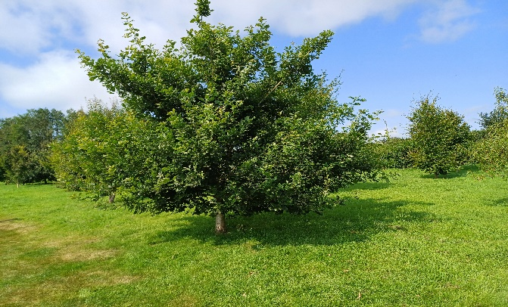importance.

The fruit trees produced a good crop this year and volunteers to prune them are requested. The crop of apples will be encouraged further with a Wassail on the 18th January, more details of this popular tradition will be circulated as soon as possible. We hope this will be supported by the community and should take place early on a Saturday evening. Please contact the Parish Clerk if you are able to help with this event.

The allotment holders have provided a number of ideas for improvements that could be made to this very important and well supported parish amenity. Additional tenanted plots would make the improvements easier. Considering the very reasonable rents, the Council are surprised there is not a greater demand. The Council look forward to working closely with representatives of the allotment holders. Anyone interested in taking up an allotment should apply to the Parish Clerk to have their names added to the list.

***Shelters, Bins, notice boards and Seats***

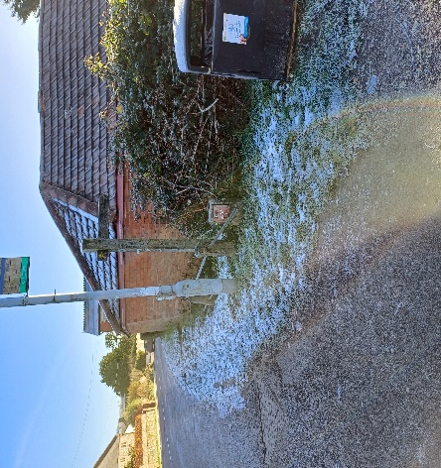When finances allow a new bus shelter is being consideration near the junction of Loveridge Lane and Fore Street. The difficulty is determining ownership, whether privately owned or Highways. Any ideas please email the Clerk.

The other bus shelters have been repaired, refurbished and repainted and an improved cleaning and maintenance plan agreed. It is unfortunate that these shelters are so badly treated by a few who spoil it for the many.  
Parking in front of waste bins prevents them being emptied with inevitable results. Action to discourage this inconsiderate practice is under consideration.

Details of the plan to increase seating benches installed in memory of members of the parish can be obtained from the Parish Clerk. We have agreed upon the bench specification and gained authority for a few roadside locations to allow our residents to donate a seating bench, or a share of a bench, as a memorial. Anyone interested in this plan should contact the Parish Clerk for more information.  
A restoration and maintenance of existing community notice boards is planned and look out for the new installation of a restored community notice board at the entrance to the Jubilee Field.

***Coombses Pond***

Efforts to obtain funding to assist with the development of this amenity continues. A basic five and ten year plan for the area has been agreed but funds are limited. The initial clearance of the entrance and surrounding path has at last been actioned allowing a clear vision of how the plan can provide a beautiful place to enjoy a natural pond. Please explore the pond but remember great care must still be taken by anyone in this wild area with its deep water and other hazards. The access and perimeter path will be kept clear of undesirable vegetation and wood piles.

All owners of land bordering watercourses have critical responsibilities. A high priority should be given to the clearance and management of the leat bordering the pond and banks of the brook to ensure the unrestricted flow of storm water. Volunteers are requested but insurance limitations restrict working party activities to using hand tools. Only those who carry a recognised certificate in using power tools in a public area will be permitted to volunteer in this way.

***Parish Green Verges and War Memorial***

More spring bulbs have been purchased and will be planted in Forton, School Lane, Jubilee field and the Cemetery. 200 have been donated to the Memorial Hall for their front bank. The Cleaning of the War Memorial, wall and fence were finished in time for Remembrance Day. Tree management and all other maintenance will continue

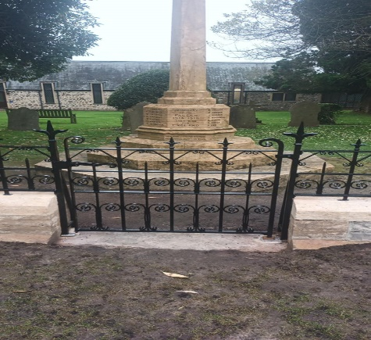

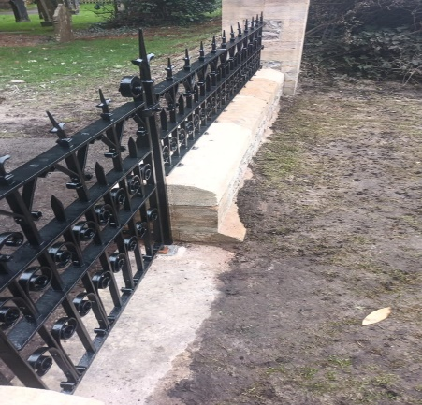

***Cemetery***

Maintenance continues to make this one of the most attractive cemeteries in the area. The Garden of Remembrance lavender hedge has been extended around the new area. The replacement of the main lavender hedge, which is 30 years old, is being considered. The Council has approved the commencement of obtaining planning permission for the cemetery extension. It is a 3-5 year process including ground water investigation with borehole drillings to meet Environment Agency requirements. The field has been owned by the Parish for many years and it is planned to offer green burials in this area. We are very pleased to welcome Jonathan Coates on to our Cemetery Committee as a co-opted member of the public.

***Planning for our area***

Work has now started on planning for our area for many years going forward.

The **National Planning Policy Framework (NPPF)** sets out the government’s plans and expectations for the whole of England.

Local authorities across the country then have to come up with a **Local Plan** for their area in line with the NPPF. Somerset Council are now working on a new Local Plan which will have a huge impact on the places in which we live. It covers housing, employment, transport, services, facilities, the environment… Parish councils have already been invited to make a quick initial submission regarding what they would like to see. We are asking for ongoing involvement as the plan is developed.

There is another type of plan called a **Neighbourhood Plan**. Back in October, a public meeting was held in Tatworth with a guest speaker who explained how this works. Whereas a Local Plan is what the council

ultimately decides for us, a Neighbourhood Plan is what we tell the council what we actually want. It sounds like a great idea – and we’d really like to thank those residents who came to the meeting with a lot of great contributions. However… the process of drafting such a plan is complex, protracted, expensive and requires a long-term commitment from a lot of local people. After much discussion, the council felt that the likely impact it would have was limited, and not worth the time, money and effort which would be required. Instead, we decided to press for our voice to be heard as the new Local Plan is drafted.

The Parish Council aims to act on behalf of people living in this area. But in order to assist with our perspective on planning, we really need a broader picture of how you see its future going forward. What do you think about housing, employment, transport, services, facilities, the environment? We would love to hear from local residents of all ages. Please let us know what *you* think!

***Youth and youth provision***

It is very regrettable that our Youth Club provider has pulled put from Tatworth for financial reasons. Despite the Parish Council increasing its contribution the lack of numbers made it financially not viable to continue. The Parish Council is still committed to providing some sort of youth events in 2025. Sadly, the lack of support from the community has meant that this service has disappeared again.

***Village Agents (Search Somerset Village Agents)***

***Parish Finances***

The Parish Council costs cover:

Community – youth provision, newsletter, grants, defibrillators, Christmas meal and remembrance.

Public facilities – ground maintenance, bus shelters, seats, cemetery

Running expenses – staff and other costs, insurance, audit fees, website

At our recent Finance Committee meeting our 2024-25 spending against budget was analysed and it was forecast that we may have a small surplus. At the same meeting we started the process of setting the budget for 2025-26. As anticipated, Somerset Council will be starting to charge us for services that previously they provided for free. We are also looking to maintain and improve the amenities in the Parish, both for Tatworth and Forton, but these costs are always increasing. (The initial analysis is that the element of your Council Tax that the Parish Council receives will increase by 50p-£1 per month, a much smaller increase than 12 months ago. This will be reviewed and the final figure approved in our January Full Council meeting).

**Dates of meetings: 5th December 2024, 16th January 2025, 6th February 2025**

Residents are very welcome to attend these meetings and do have an opportunity to speak before the meeting about any matter not on the agenda.

If you have any questions or feedback arising from this newsletter, please send them to [admin@tatworthandfortonparishcouncil.org.uk](mailto:admin@tatworthandfortonparishcouncil.org.uk).

As this is the last newsletter of 2024 the Parish Council would like to wish all residents within our Parish a very Merry Christmas and a successful New Year