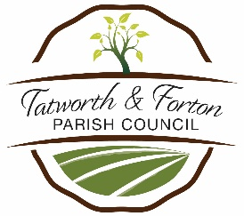**TATWORTH & FORTON PARISH COUNCIL**

**POLICY FOR COMMUNICATION WITH THE PRESS AND PUBLIC**

Adopted on 3 August 2023

Minute No 98/23

MEDIA

1. The Clerk will clear all press reports, or comments to the media, with the Chair of the council or the Chair of the relevant committee.
2. Press reports from the council, its committees or working parties should be from the Clerk or an officer or via the reporter’s own attendance at a meeting.
3. Unless a Councillor has been authorised by the council to speak to the media on a particular issue, Councillors who are asked for comment by the press should make it clear that it is a personal view and ask that it be clearly reported as their personal view.

PUBLIC

1. Facebook notices, Newsletters and announcements from the Council or its committees should be made by the clerk or an officer of the Parish Council under the PC’s name.
2. Unless a Councillor is absolutely certain that he/she is reporting the view of the council, they must make it clear to members of the public that they are expressing a personal view.
3. If Councillors receive a complaint from a member of the public, this should be dealt with under the Council’s adopted complaints procedure, or via a council agenda item.